1.0 INTRODUCTION

1.1 Background
Despite the socio- economic benefits that accrue from the roads sub-sector interventions, the Government of Uganda is aware that sub-sector activities and working environments are associated with a number of occupational accidents, injuries and diseases that affect. workers, adjacent communities and road users. These are exposed to physical, chemical, biological, mechanical and ergonomic risks and hazards. The hazards range from noise, air and water pollution, to the spread of HIV/AIDS and other sexually transmitted diseases (STDs). Traffic accidents are also a major concern causing disability problems, permanent injuries and death, the economic and social cost of which is extremely high for the country.
Besides the negative impact on the physical environment, the government is also aware of the margnalised groups of the society, including children, women, migrant labourers, people with disabilities (PWDs) who work in unsafe and unhealthy conditions characterised by long hours, low pay, and physical and psychological abuses. These factors are compounded by low levels of awareness and competence among many of the sub-sector employers and absence of active workers’ bodies as well as poor reporting of accidents and data management.
The government is also concerned with the economic costs of occupational accidents and diseases in terms of work time and productivity, compensation and medical expenses and accidents damage.

1.2 Justification of the Guidelines
In order to address the above concerns, the Ministry has prepared a Policy Statement which commits itself to ensuring that OHS concerns are mainstreamed into all phases of the roads sub-sector policy formulation, programming, identification, design, appraisal, implementation, monitoring as well as evaluation. One of the strategies for implementing the Policy Statement is to develop guidelines, which are intended to translate the statement into action at all stages of the planning sub-sector activities.
The obligation to prepare these Guidelines is derived from relevant national legislations and policies including the Constitution of Republic of Uganda, 1995 and Factories Act, 1964. The Guidelines will translate these legal and policy provisions into specific sector practices.
The MoWHC has already taken the initiative to mainstream OHS into the sub-sector policy documents, as well as developed OHS Guidelines such as the District Administrative and Operational Guidelines. MoWHC, however, recognises the need for developing nationally relevant Guidelines for mainstreaming OHS in the sub-sector. These Guidelines have been developed as a practical strategy for ensuring that OHS is translated into actions and is explicit in all the sub-sectors’ institutions, policies, plans, programmes and budgets. The District Guidelines have been incorporated in this document and will supplement the national guidelines at the local government level.
By developing these Guidelines, the MoWHC will contribute to the translation of the national and sectoral policies into commitments to comply with health and safety standards through ensuring that OHS is explicit in all its policy and other line documents. Implementation of these Guidelines will strengthen the sub-sector’s contribution to economic growth and poverty eradication through promotion of safety and health at the workplace, improvement of working conditions and industrial relations that are crucial for increasing productivity as well as protecting vulnerable persons from being exploited. The guidelines also expected to improve accessibility to services and safe and healthy paid work with a view to enhancing income and improving the quality of life..
1.3 Goal
The overall objective of the Guidelines is to strengthen the roads sub-sector’s capacity to mainstream OHS in roads sub-sector in order to reduce work-related hazards, injuries and illnesses and to improve the well being and the quality of the work environment of the workers and other affected persons.
1.4 Purpose
The purpose of the guidelines is to provide clear processes and procedures so that OHS concerns are addressed in planning, implementation, monitoring and evaluation of all roads sub-sector activities.
1.5 Specific Objectives
- To provide employers in the sub-sector with a clear structured approach to improvement of health and safety in the workplace.
- To ensure that people other than only sub-sector employees are not exposed to health risks while at proximity and use of the existing roads infrastructure, services and means of transport.

1.6 Preparation of the Guidelines
The Guidelines are based on a comprehensive analytical and consultative process involving a number of sub-sector stakeholders at both national and local government levels. They also draw on good practices of mainstreaming OHS in different sectors, programmes and projects in Uganda and elsewhere. The District OHS Guidelines have been incorporated into this document and will supplement the national guidelines at the local government level.
1.7 Scope of the Guidelines
The Guidelines are step-by-step working tools and methods which intended tol guide the sub-sector and its partners during policy formulation, planning, project preparation studies, procurement of contractors and consultants, supervision of all road construction projects, environmental/ socio-economic impact assessments, and monitoring and evaluation of projects in the roads sub-sector.
The Guidelines include questions as well as checklists in the form of indicators, all to be used as internal tools for monitoring compliance of the sub-sector with regard to OHS. The Guidelines apply to all sub-sector interventions and institutions that are clearly spelt out in the Policy Statement. In addition, they also give guidance on how the MoWHC staff capacity can be built effectively to mainstream OHS in the sub-sector.

The Guidelines describe how the key stakeholders can be brought on board in the mainstreaming of OHS process, and the roles they are expected to play in line with the national laws and regulations governing OHS.
1.8 Target Users
The intended key users of the Guidelines include:
1. Ministry of Works, Housing and Communications
- Roads Department staff in the designing, maintenance, supervision and monitoring of road projects.
- Quality Management in terms of developing and reviewing of standards, manuals, guidelines and undertaking audits of road works.
- Transport Planning Department in the process of strategic planning, co-ordination, performance indicators and impact studies
- Finance and administration budgeting, policy formulation, human resources and legal matters.
- Policy Analysis Unit in the preparation of policies, especially the Budget Framework Paper and Ministerial Policy Statements.
- Contracts Committee in the procurement process of services.
- Procurement and Disposal Unit in the procurement and biding process.
- Mount Elgon Labour Based Training Centre (METC) in the revision of its training curriculum.
  - Road Agency Formation Unit (RAFU) and eventually Uganda National Road Authority in the process of design and supervision of national roads projects.
  - Road contractors during the implementation of road projects.
  - Consultants for the sub-sector during technical studies, designs and supervision of contractors.
  - Road Safety Council- includes OHS in road safety campaigns.
  - Private bus and taxi operators- in the provision of services and facilities to public.
  - District Local Governments in procurement of services and their subsequent implementation.

1.9 How to use the Guidelines
These Guidelines will be used together with other guidelines and user manuals that have been developed by MoWHC for mainstreaming cross-cutting issues relating to the environment, HIV/AIDS, gender, PWDs /older persons.

- KEY STEPS IN MAINSTREAMING OHS IN POLICIES, PLANS AND PROGRAMMES

2.1 Overview

These Guidelines present a step-by-step approach in mainstreaming process of OHS and include questions as well as a checklist in the form of indicators. The checklist is to be used as an internal tool for monitoring compliance of the sub-sector policies, plans, programmes and budgets. Effective mainstreaming of OHS will also require at certain instances modifying, reorganising and improving the sub-sector’s institutional, operational and regulatory procedures and processes. This entails the following sequential steps:

2.1.1 Steps

- Situation Analysis and Document Review;

- Review to update and incorporate all OHS policies, procedures, manuals and guidelines that are used with respect to sub-sector institutions;

- Putting in place institutional structures, procedures and processes to oversee and co-ordinate the mainstreaming process within institutions and its stakeholders.

- Formulation of sub-sector policies, plans, budgets and projects that integrate OHS, among other cross-cutting issues. These should be in agreement with national legislations.

- Improving institutions’ awareness and commitment mainstreaming through training.

- Developing mechanisms to implement a safe and healthy conducive working environment.

- Developing monitoring, evaluation and management information systems to track changes with respect to occupational safety and the health of sub-sector personnel and road users.

2.2: Step 1: Situational Analysis and Document Review

In order for the roads sub-sector policies, plans and budgets to take cognisance of OHS, all its interventions need to be reviewed to identify gaps and areas which are likely to result in situations which may compromise health and safety standards. Policy and documentary review will be preceded by a situational analysis, which is to be undertaken by the Policy Analysis Unit in collaboration with the Environmental Liaison Unit.

2.2.1 Situational Analysis
A detailed situational analysis of the entire sub-sector will be conducted to:
- determine the potential negative impact of sub-sector interventions with respect to the health and safety of the workers, users and communities in terms of gender, age, occupations and abilities.
- determine who is affected and likely to be affected, how and why in terms of gender, age, occupational and ability, with respect to OHS.
- identify critical activities of the sub-sector which compromise the health and safety standards.
- assesses the adequacy and gaps in practice of the measures to meet safety and health standards.
- assesses the appropriateness of programmes intended to build the capacity of stakeholders to address and manage OHS.
- Identify a set of Set priority interventions s to address OHS concerns in the roads sub-sector.

The environment Audit can also be used as a tool to assess the potential negative impact with respect to the existing and on-going interventions. The environment Audit studieswithin the roads sub-sector will have clear sections on the working environment and the psychosocial environment of the project or programme. In particular, the environment audit will identify the extent to which the existing and on-going interventions are complying with the standards to reduce the work place hazards as well as psychosocial hazards spelt out in the proposed Environmental Action Management Plan.

Step 2: Review of Existing Policies, Programmes, plans an Projects

All sub-sector policies, plans and budgets will be reviewed to establish their levels of compliance to OHS provisions, and to identify gaps that should be addressed. It is the responsibility of the Policy Analysis Unit in consultation with other departments to develop sub-sector policies and plans and its capacity will be therefore be enhanced enable them to play their respective roles during the OHS mainstreaming processes.

The review process of policies and programmes will focus on and guided by the following questions:

whether there is a there is a policy statement(s) expressing commitment to:
- protect workers, road users and the general public against related hazards, injuries and illnesses.
- address other issues of HIV/AIDS, gender, and the environment with strong clear links to social protection sector.
- improve the capacities of the sub-sector partners and service providers to mainstream OHS.
- provide and maintain a healthy working environment and safe systems of work.
- put in place mitigation measures to prevent, reduce and control likely hazards, risks and illnesses.

Principles and Values:
- Is improving the quality of life of staff, workers, road users and adjacent communities (of various gender, age, occupational and ability groups), one of the explicit guiding principles of the policy?
- Do the beneficiaries include both workers and other persons of various gender, age, occupational and ability groups?

Strategies
Do planned strategies:
- involve capacity building to raise their awareness of the content and importance of OHS?
- include clear and realistic measures to mitigate the negative impact of sub-sector activities that threaten the health and safety of workers, road users and adjacent communities (of various gender, age, occupational and ability groups)?
- involve development of monitoring and enforcement mechanisms to prevent, reduce or increase hazards, accidents.
- address the gaps and factors that increase hazards?
- create/ reinforce potential negative impacts on the sub-sector?
- involve development of a communication strategy informing various stakeholders and the public about the existence of roads project?
- consider the potential negative impact of the interventions.
- make budgetary provisions for the OHS interventions

Implementation Modalities
- Have the partners received training on OHS?
- have processes and structures been put in place to oversee and sustain the process of OHS mainstreaming?
- Are roles clearly defined for the various actors to implement the planned OHS interventions?
- Will both men and women participate in implementation of the interventions?

Monitoring and Evaluation Framework
- Does the sub-sector monitoring and evaluation framework explicitly take OHS concerns into account?
- Does the sub-sector monitoring and evaluation framework examine both substantive and administrative aspects of the interventions?
- Are indicators gender-sex-disaggregated?

Box 2.1 Checklist of Pertinent Policy Documents for OHS Review

- Draft Transport Sector Policy and Strategy (2003)
- Updated Road Sector Development Plan (RSDP2)
- 10-Year District Roads Investment Programme (TYDRIP)
- Final Draft White Paper on Sustainable Maintenance of District, Urban and Community Access Roads (MoWHC, 2002)
- Workplace Safety and Health: Guidelines for District Engineers (MELTC, 2003)
- Road Sector Programme Support Document, 2002
- Transport, Housing and Communication Sector, Ministerial Budget Policy Statement, 2003
- Transport, Housing and Communication Sector, PEAP Review Paper, 2003
- Transport, Housing and Communication Sector, Budget Framework Paper,

District Road works Manuals
- Prequalification / bidding documents and contract documents
- Roads design and maintenance manuals
- General and Specifications for Road and Bridge Works, 2005

2.3 step 3: Mainstreaming OHS in Sub-sector Institutions

Effective mainstreaming of OHS requires re-organisation of the institutional procedures as well as modifying and improving the sub-sector institutional, operational and regulatory procedures and processes. This will require the sub-sector to:
- develop implementation frameworks with clear targets and indicators that integrate OHS within the operational work;
- designate an Officer providing the leadership for OHS mainstreaming activities;
- have a budget provisions for OHS mainstreaming activities such as awareness-creation and capacity building.
- develop OHS policies and programmes geared towards improving occupational health and safety.

2.3.1 Mainstreaming OHS into MoWHC Structures and Processes

In order to effectively mainstream OHS in its structures and processes, MoWHC will have to undertake the following proposed activities:
- Set up a Joint Safety and Health Advisory Committee, composed of key stakeholders to advise on health and safety policies, guidelines and procedures.
- Develop mechanisms to implement OHS strategies spelt out in the OHS Policy Statement to ensure that OHS is fully integrated all sub-sector policies, programme and activities.
- Enhance the capacity of the Quality Management Department to monitor compliance by the sub-sector stakeholders, with ELU providing technical input and oversight for operationalising the action plan for implementing the OHS Policy Statement.
- The capacities of the Quality Management Department and the ELU will need to be strengthened to be able to monitor compliance and provide technical support
- The DUR will take the role in guiding Local Governments Works departments to reflect OHS in plans, budgets and bills of quantities (BoQ).
- RAFU as the authority that will take over the implementation of the major road sector development programme (RSDP) projects, will be obliged to ensure that OHS concerns are observed in all the works for which the authority is responsible.

2.3 2 Operationalisation OHS Mainstreaming in MoWHC

OHS mainstreaming in MoWHC will involve the following:

- planning/ formulation, implementation and monitoring of policies programmes and activities of the Ministry to ensure that they integrate OHS considerations;
- preparation the Ministry’s budget with provisions of costs relating to cross cutting issues;
- development of engineering standards and manuals with provisions of OHS, among others;
- preparation of tender and contract documents with BoQ reflecting OHS costs.
- planning, design, implementation, maintenance, monitoring and evaluation of road projects to ensure compliance with OHS;
- management of human resource taking into consideration OHS concerns; and
- undertaking technical and impact assessment studies with clear provisions for OHS aspects forming part of such studies where necessary.

2.3.3 Partnership in OHS Mainstreaming Process

MoWHC will develop appropriate mechanism to collaborate with other line ministries and lead agencies to promote OHS institutionalisations in the sub-sector. Such Partnership will involve the following agencies and ministries:
- The Ministry of Gender, Labour and Social Development (MGLSD), supervise, investigate work-related accidents, and monitor and review safety and health-related issues in the sub-sector. The ELU will provide information on progress of on-going sub-sector programmes and activities.
- The Ministry of Public Service’s Standing Orders will continue guiding the welfare s (with respect to OHS) of civil servants working in the sub-sector.
- The Ministry of Health (MoH) and the District Director of Health Services will provide guidance with respect to health hazards that arise from biological agents (sanitation, vectors, waste disposal, waterborne diseases and clinical aspects) during road construction, use and other work.
- The Ministry of Internal Affairs (Traffic Department) will strengthen the enforcement of relevant laws on safety and health (noise levels), test and issue certification for motor vehicle drivers in different categories, investigate accidents and incidents on the roads and provide input on the best methods of reducing them.
- Ministry of Finance, Planning and Economic Development will be instrumental in terms of MoWHC sectoral budget approval with OHS budget lines. OHS will also be included among the crosscutting issues of PEAP and criteria for eligibility of PAF and LGDP. MoWHC will provide relevant information on OHS to the Uganda Bureau of Statistics (UBOS) for inclusion in collection, analysis and interpretation of national data. The progress reports shall also be submitted to the MoFPED Poverty Monitoring Unit to be reflected in Poverty Status reports and revision of the PEAP.
- The Ministry of Local Government and Local Governments (District and Urban authorities) will monitor to ensure that local and urban authorities integrate OHS and other cross-cutting issues and that contractors develop and implement measures for OHS compliance.
- The National Environment Management Authority (NEMA) has developed and/or adopt guidelines and standards for noise and air pollution, waste discharge among others. In addition, it will demand inclusion of OHS in the EIAs, EIRs and Environmental Audits. NEMA will receive from MoWHC, Environment Impact Assessment Reports for Projects, study, comment and approval.
- Uganda Revenue Authority (URA) jointly with National Bureau of Standards are central to clearance of vehicles, materials and equipment entering the country ensuring that they comply with OHS standards.
- National Roads Safety Council will promote awareness about road safety.
- Consulting Engineers are to supervise contractors on quality of physical works and also on the implementation of OHS measures over the entire duration of the road projects.
- Contractors will be responsible for the application of the safety and health measures in respect of the workers placed under their respective contracts over the entire duration of the projects.
- National Employers and Employees Associations (NOTU and FUE) will develop OHS policies, with comprehensive OHS management and monitoring plans, that will be followed by their members and will be required to have OHS training programmes for their members.
- Development Partners to continue assistance to MoWHC and harmonise their conditionality with respect to OHS.

Step 4: 2.3 Capacity Building

In order to improve MOWCH awareness and commitment to occupational health and safety, the capacities of both MoWHC (especially ELUS and Departments of Roads) and its key stakeholders will be enhanced through training. Stakeholders need to appreciate the importance and value of health and safety to workers, good industrial relations and corporate image, besides efficiency considerations. This is to be achieved through capacity building which will involve:

- The Training Division in liaison with ELU will develop capacity building programmes to raise awareness on the importance of OHS in the roads sub-sector.
- ELU will collaborate with other relevant organisations to facilitate regular training and sensitisation programmes to ensure integration of OHS in their programmes.
- The training programme will be guided by the following guidelines:
- The training will focus on awareness-creation to deepen understanding of the concept and value of OHS within the context of the stakeholders’ work as well as developing their skills to execute their respective work while taking into account OHS concerns.
- A comprehensive training needs assessment will be conducted to identify training needs and to develop tailor-made OHS courses for the different stakeholders.
- Owing to the different levels of knowledge and mandates of target groups, the training will be based on capacity needs and tailored to focus groups.
- MoWHC shall organise training of trainers (ToT) courses for the sub-sector institutions such as RAFU, the Uganda Association of Consulting Engineers (UACE), the Uganda National Association of Building and Civil Engineering Contractors (UNABCEC), the Engineers Registration Board as well as the Road Safety Council. The purpose will be to build a pool of OHS trainers that the respective institutions can draw upon.

The checklist in box 2.2 highlights the expected capacity as a result of OHS training programmes for the sub-sector stakeholders
Box 2.2: Checklist of expected outcome of OHS Training Programme

- MoWHC/RAFU top management ensure commitment and advocate allocation of resources
- Quality Management capacity is enhanced to ensure compliance and that OHS and other cross-cutting issues are incorporated into development, maintenance and all related sub-sector standard manuals and guidelines.
- The capacity of Roads Department RAFU and Local Governments are built to incorporate OHS during development and maintenance, supervision and monitoring of national, district, urban and community access roads that take into account health and safety issues
- ELU and RAFU capacity is improved to ensure the incorporation of OHS into environmental impact assessments
- Department of Transport Planning capacity is strengthened to incorporate OHS into road transport strategic planning, co-ordination and performance monitoring; socio economic impact studies related to modes of transport; the collection, analysis, interpretation and dissemination of data on transport modes
- The capacity of Finance and Administration Department is enhanced mainstream OHS into personnel management, policies, regulations, practices and procedures; formulation and management of Ministry’s budget co-ordinated and in handling ministry’s legal matters.
- Policy Analysis Unit capability is improved to mainstream OHS in formulation and review of sub-sector policies and in regulatory environment impact assessment
- The capacity of DUCAR staff is strengthened to guide Local Governments Works Department to reflect OHS in plans, budgets and procurement of works.
- The capacity of Contracts Committees of MoWHC and RAFU is enhanced to incorporate OHS in the sub-sector’s contracting process
- MoFPED Transport Desk to incorporate OHS in the sub-sector budgets, PEAP, PAF and LGDP
- Consultants capacity enhanced to appreciate the need to take into consideration OHS in executing technical studies, technical designs and supervision of contractors
- Contractors competence and understanding are improved to address OHS concerns during the implementation of road works.
- Private transport operators to equally address OHS concerns with respect to provision of services and facilities to passengers
- Road Safety Council in their campaigns to integrate OHS in their awareness campaign.

STEP 5: 2.5. Mainstreaming OHS into the Formulation of Policies, Plans, Programmes and Budgets

2.5.1 Planning Stage
Development of all roads sub-sector policies, plans and programmes shall all take into account health and safety of sub-sector personnel as well as factors that compromise compliance to national OHS standards. In order to develop concrete strategies that mitigate potential hazards, with clear objectives and performance indicators, the following steps are recommended:

- Sector policies, programmes, plans and budgets are assessed with the help of strategic environment impact/social impact assessment tools to determine their long-term and cumulative impact on the people and with a view to:
  - Set sector goals and objectives that shape broad long term visions with respect to OHS;
  - Define a vision of the sub-sector with respect to OHS;
  - Set specific objectives, targets, criteria and indicators with respect to OHS;
  - Define alternative means and mitigation measures to comply with national health and safety standards;
  - Identify opportunities and constraints which OHS concerns places on development;
  - providing guidelines to ensure that development is within sustainable limits.

The role players in strategic environment assessment are ELU and PAU in MoWHC.

The formulation of sector interventions will be guided by the following questions:

a) Project Identification
- How consultative is the prioritisation? Does it involve the workers, workers’ associations and the other sector stakeholders?
- Are both women and men consulted?

b) Project Design
- Are hazard and risk assessments adequately carried out in the sub-sector?
- Are measures designed to eliminate or control the hazards and risks identified?
- Are modifications, substitution or elimination of materials affected to mitigate the use of dangerous structural, or other procedures or materials hazardous to health or safety?

c) Resource Allocation
Are resources allocated for of mitigating the identified potential negative impacts on both women and men?

d) Project Appraisal
- Are assessments of risks and hazards conducted to identify the impact on workers and road users (in terms of age, gender, occupation and ability groups?)
- Are mitigation measures put in place to address the potential negative impacts of the plan/programme or project?

Hazards and Risk Assessment

Assessment of hazards and risks are undertaken at project level and are part of the EIA conducted to assess likely hazards and risks and their negative impact on the safety and health of workers, users and communities and the physical environment. This stage involves the steps which are part and parcel of environment impact assessment and therefore reflect the need for mainstreaming OHS in the EIA. These include

- Screening to identify potential negative impacts and designing mitigation measures to reduce hazards.
- Project briefs which are prepared by MoWHC/ Local Government to identify positive and negative impacts and areas to be affected, the extent to which design, raw materials, products to be used are and their compliance to the national health and safety standards.
- Scoping is carried out with stakeholders to identify OHS issues (to be included in the Impact Study Review) with respect to alternative designs, plants and machinery and materials which are less hazardous and other mitigation measures to control negative impacts. MoWHC, with the assistance of experts/consultants will conduct the scoping with the full participation of communities, other government agencies and civil society organisations.
- Environment Impact Study will be undertaken by consultants with knowledge of OHS and the ToRs will make a requirement to highlight OHS issues with respect to the recommended technologies, processes and methods of work, raw materials impacts and mitigation strategies. The analysis is to provide alternatives and contain management and monitoring plans.
- EIS reviews to determine whether the EIA provides adequate assessment of hazards as required in the ToRs risks and other potential impact and related mitigation measures.
- Detailed design stage which incorporates the mitigation measures that were identified during screening, scoping and impact studies to address OHS concerns are integrated by RAFU experts and consultants while ELU/MoWHC links the process with NEMA for approval.
- Contract preparation stage with relevant clauses and conditions in the tender and contract documents for the consultants and contractors to implement projects which make it obligatory to comply with OHS provisions.

OHS as Obligatory Part of Environmental Assessment Statement
Every Environmental Assessment (whether Environmental Impact Assessment or Environmental Assessment and Environment Audit) within the roads sub-sector will have a clear section on OHS. Possible mitigation measures for work hazards and psychosocial hazards will be spelt out in the proposed Environmental Action Plan. When a project contract has been awarded, these will then form the starting point for the OHS expert who will be engaged by the Contractor or the District Engineer, as the case may be, to carry out the detailed OHS hazards identification and develop an OHS action plan.

Step 6: 2.6. Ensuring OHS Compliance During Implementation

2.6.1

Implementation of sub-sectoral OHS related interventions is the responsibility of both local governments as well as private sector (consulting and contracting firms that are sub-contracted by MoWHC/RAFU and local governments). The District Guidelines will be used to supplement the implementationOF checklist and questions below at the local government level.

OHS shall be incorporated into ToRs, pre-qualification, bidding and contract documents by the Procurement and Disposal Unit of MoWHC/RAFU and the District Tender Boards in order to ensure that the private sector (the key implementers), whose primary motive is profit maximisation, addresses OHS concerns. Potential consulting and contracting firms must, therefore, demonstrate clear sensitivity and competence to deal with OHS concerns.

Key Compliances Questions

- Do the ToRs clearly specify the need for an OHS expert on the consultant’s team?
- Do the ToRs explicitly incorporate objectives and expected outputs with respect to OHS?
c) Do the ToRs explicitly provide for utilisation of methods to identify hazards, risks and mitigation measures during all implementation stages?
d) Do the pre-qualification and bidding documents indicate a need for consultants/contractors with capacity to address OHS concerns?
  - Does the certificate of completion of works reflect the need for compliance with OHS?
  - Do the Bills of Quantities provide for sociological estimates to cover costs related to mobilisation, awareness-creation, enabling a safe and healthy working environment and participatory monitoring?
  - Does the contract document oblige the contractor to provide for:
- equitable mobilisation and recruitment of workers?
- reward or sanction for compliance or non-compliance, respectively?
- training skills for road workers?
- compensation schemes to benefit those who become victims of accidents?
- protective wear
- emergency health facilities at construction sites to enable the provision of instant first aid for victims of accidents and other hazards?
- safety mechanisms at workplaces and equipment that reflect operations and maintenance concerns?
- plans for reducing accidents, which frequently lead to causes of disability in the road construction and maintenance processes?
- monitoring adherence to safety rules?

The checklist for monitoring compliance of the above questions are summarised in annex 7

Annex 7: Checklist for Assessing of Consultant’s/contractor’s profile

  - OHS is one of the preconditions for pre-qualification of the bidderS.
  - OHS is among the criteria for evaluating bid submissions.
  - Financial proposals and BoQ include clear items, which take care of OHS ?
  - ToRs clearly include a requirement for an OHS expert on the team, and the capacity, experience and methods of incorporating OHS in the assignment.
  - ToRs clearly stipulate the need to include an OHS expert on the consultant’s team.
  - ToRs explicitly incorporate OHS objectives and expected outputs.
  - ToRs explicitly provide for utilisation of methods to identify hazards and mitigation measures.
  - Pre-qualification and bidding documents provide for OHS requirements on consultants and contractors.
  - Contract includes clauses obliging contractors and consultants to comply with OHS requirements.

3.0 MECHANISMS TO IMPLEMENT OHS CONDUCIVE WORKING ENVIRONMENT
Roads sub-sector worksites, and all off road works sites such as offices, workshops, quarries and parking yards will develop:

3.1 OHS policy, with a commitment to ensure safety and health of its workers. All written policies will be backed by a written operationalisation manual or guidelines which will be available to all workers. The policy will also be supported by an OHS programme with a detailed safety method statement aimed at identifying and preventing the occurrence of any likely work hazards as well as checking compliance with various OHS obligations related to them. The scope of the OHS programme should promote health and safety, prevention of diseases and injuries, treating occupational and general ailments, and embrace physical, social and psychological rehabilitation. This programme shall involve:
  - Identifying, assessing and controlling hazards effectively and promptly;
  - Accident reporting, investigation and analysis;
  - Establishment of a mechanism for employee consultation and participation
  - Provision of first aid and PPE;
  - Institution of emergency procedures and fire protection;
  - Site and task-specific OHS training;
  - A rehabilitation programme;
  - Addressing all the employees’ health and safety concerns including HIV/AIDS; (as indicated in the MoWHC Policy Statement and Guidelines for mainstreaming HIV/AIDS); and
  - Non-discriminatory workplace activities and programmes to protect the staff and employees living with HIV/AIDS;

  - Health and Safety Education, Information and Communication

Each work site in the roads sub-sector will have in place an active OHS information, education and communication programme. Training will be based on needs assessment, which should be action oriented and reflect the local sector-specific situation focusing on:
    - new employee induction and training; refresher training; in-house training;
    - establishing training packages for new workers and new work assignment;
    - training of trainers on practical risk assessment skills and finding feasible solutions;
    - provision of well-packed information in order to assist in training;
    - development of information sheets describing hazards, preventive measures and emergency procedures;
    - establishment of an Information, Education and Communication (IEC) programme including HIV/AIDS sensitisation to influence behaviour and educate workforces and the communities on HIV/AIDS; and
    - institution of measures that promote use of protective equipment and condoms to ensure safety and health.

  - Health and Safety Promotion

This will focus on:
- Disease and accident prevention, promotion of health and safety practices, disease and injury prevention activities, emergency and routine treatment, as well as rehabilitation of workers.
- elaborate first aid services (See Annex) located within immediate access of the employees being served.
- First aid kits should be provided at workplaces including isolated locations and must be protected against contamination by dust and moisture.
- The first aid boxes should not contain anything besides materials for first aid in emergencies.
- First aid boxes should contain simple and clear instructions to be followed, be kept under the charge of responsible persons qualified to render first aid and be regularly inspected and properly stocked.
- health and safety committees will be set up to regularly monitor health and safety standards.
- incidents, accidents (major, minor or near misses) injuries, diseases of employees at all worksites will be recorded
- effective counselling policies for HIV-positive workers and communities to encourage infected individuals to live positively.
- standing arrangements for medical care on site or to the nearest health service in the shortest time possible
- adequately equipped with staff, laboratories and drugs to test, diagnose and treat sexually transmitted diseases (STDs) and HIV/AIDS opportunistic diseases.
- all workers should be subject to health surveillance and whenever new products, equipment and working methods are introduced, special attention should be paid to inform and train workers as well as promoting awareness of the need to safeguard their health.

  - Mitigation Measures to Reduce Hazards

This will focus on:
- potential hazards (including explosives, fires, fumes, dust, detonation and blasting operations, falling/moving objects and equipment, corrosive and toxic materials, vibrations, noise) at roads sub-sector work settings should be identified and appropriately controlled or eliminated.
- manufactures, importers and suppliers of hazardous products used in the sub-sector should be required to provide information with the products together, in the appropriate language, on associated health risks and the precautions to be taken.
- hazardous substances should be clearly labelled, giving their relevant characteristics and instructions on their use and should be handled under conditions prescribed by national laws and regulations.
- containers of hazardous substances should be accompanied by instructions relating to the safe handling and disposal of the contents and procedures to be followed in case of spillage.
- the competent authority (MGLSD or NEMA) should determine which hazardous substances should be prohibited from use in road construction machinery.

  - Elimination of Hazards arising from Chemical, Physical and Biological Agents and Climatic Conditions:

Measures to limit hazards that arise from the above agents and climatic conditions will involved the following:

- Replacement of hazardous substances, equipment or process with those which are less harmful to workers’ safety and health;
- Reduction of noise and vibration caused by equipment, machinery, installations and tools;
- Control of the release of harmful agents or chemicals into the work environment;
- Proper working postures when workers are required to work in fixed working positions or in carrying out repetitive work;
- Appropriate protection against climatic conditions that are likely to jeopardise health;
- Instituting work practices which will eliminate or minimise danger to safety and healthy.
- Supplying and insisting on use of personal protective equipment and clothing
- Provision of cables of portable electrical lighting that are of adequate size to withstand severe conditions in construction operations.

3.6 Equipment and Workplace Ergonomics

All equipment, machinery and tools used should have safety manuals and safety instructions for proper ergonomics. All employees should be instructed on the safe use of the equipment. These applies to:
- Offices (e.g. chairs and tables of adjustable height, computers with anti-glare screens);
- Mechanical and maintenance workshops (e.g. ladders for accessing high file cabinets, stable and non-slip floor surfaces);
- Road worksites (e.g. handling gear for hot, cold or sharp surfaces, lifting aids for heavy objects );
- Quarry sites (e.g. roof support structures, working space, lighting and ventilation)
- Borrow pits (soil stability, gradient of slopes);
- Where natural lighting is not adequate, appropriate lighting should be provided but artificial lighting should not produce glare or disturbing shadows

  - Personal Protective Equipment

Workers should be provided with appropriate personal protective equipment (PPE) whose use should be monitored and worn out ones should be replaced regularly. Other considerations are:
- Suppliers of equipment, machinery and tools to be used on roads sub-sector works and support sites will be required to provide manuals and instructions on their equipment and to ensure that all employees are instructed on the use of such equipment.
- Workers in the field and in offices should work within a safe and ergonomically comfortable environment.
- Appropriate personal protective equipment should be provided to all workers directly employed or contracted in the roads sub-sector.
- Use of protective equipment and condoms to ensure that employees are not put at risk of illness and injury, which can result in HIV/AIDS infection and transmission should be promoted.

  - Workplace Safety Measures

To ensure that all workplaces are safe without risk of injury to the workers and to protect the persons in vicinity of work, the following should be borne in mind:
- adequate and safe means of access to from all workplaces;
- proper storage of materials and equipment;
- removal of scrap, waste and debris at appropriate intervals;
- cleaning up of the workplace and pass-ways that are slippery owing to the presence of oil;
- fencing of sites near and alongside vehicular and pedestrian traffic routes with visible signs to regulate entry;
- putting up appropriate measures to avoid the risk of outbreak of fires.
- Fire-extinguishing equipment should be properly maintained and inspected and all workers trained on their proper usage;
- suitable storage of flammable liquids, solids and gases and prohibition of smoking with visible notices around places with easily combustible or flammable materials; and
- regular inspections of places where the risk of fire is high.

  - Equipment

Plant, machinery, equipment and hand tools (both manual and power driven)should:
- be fitted with devices for maximum safe speed, while power-driven machinery should be provided with adequate means to stop it moving accidentally;
- be of good design and construction, taking into account health and safety as well as ergonomic principles;
- be maintained in good working order and used for the right work for which they were designed and should in addition be operated by an authorised and trained worker;
- be operated by workers provided with protective guards, shields and other PPE as required by national laws and regulations; and
- having dangerous moving parts enclosed and guarded adequately

3. 10 Underground Work

When work involves excavations, shafts earthworks and general underground work, the following should be observed:
- Adequate precautions should be taken in any excavation, shaft earth, underground works and need to be inspected by a competent person before start of such work;
- Such works should be carried out in accordance with plans approved by competent authorities as required by laws and regulations;
- Such works should have an in-built mechanism to enable workers to reach safety in the event of fire or inrush of water or material, and protect workers from one risk of circulation of fluids and gas;
- Should be traversed by regular air current to keep them fit for working to avoid excessive rises in temperature, dilute harmful dust, gases, vapours and fumes; and
- No combustible structure should be build or any flammable material stored, and naked lights, smoking and petrol engines should be avoided.

  - Transport Storage and Handling of Explosives

Transport, storage and handling of explosive should be guided by the following:
- All explosives supplied should be accounted for and recorded and the unused ones be returned to the storage facility;
- Road and rail vehicles used for transport should be in good running conditions, tightly covered and clearly marked that they carrying explosives;
- Explosives and detonators should be transported separately from to the workplace storage.
- different types of explosives should not be transported in the same container;
- Explosives should not be conveyed in a shaft cage with other materials. Also workers should not be transported in the such cars;
- Before using such explosives, an agreed system of work should be prepared and the responsibilities of persons involved detailed in writing;
- Dynamite should not be removed from its original wrapper till the time of loading into drill holes;
- Blasting should be done off shift or during breaks of work, as this can endanger workers and the adjacent communities. Blasting times should be agreed and shots should not be fired before adequate warning is served to the community.
- Lookout and warning flags should be posted around the blasting areas to prevent persons from entering any danger zones;
- Measures should be put in place to prevent formation of dust .
- Explosives should be destroyed in conformity with the manufacturer’s instructions, no person should be within 30 m of a fire in which wrapping or packing materials are burned and they should not be burned in a stove, fireplace and other confined space.

3.12 Road Safety in the Roads Sub-sector
In order to enhance road safety along road networks and construction sites, the following should be noted:

- Work sites should hold regular defensive driving and general safety training and refresher training for all drivers of all categories
- drivers of all categories of vehicles should be assessed for their suitability for their specific jobs/tasks.
- there should be an adequate number of flag persons along stretches of the road where construction works are active. The responsibility of such workers is to warn traffic about the diversions and other activities taking place on the construction works.
- adequate measures should be clearly put in place to regulate the speed and motion of regular traffic and construction works traffic.
- all vehicles and earth-moving or materials handling equipment should be inspected daily, be of good design and construction taking into account ergonomic principles with reference to their seats.
- Vehicles should be maintained in good working order and operated by workers in accordance with national laws and regulations, who are medically fit, trained, tested and of a prescribed minimum age .
- special safety precautions should be taken when moving backwards, when operating in dangerous proximity to live electrical conductors, preventive measures should be taken to avoid falling into excavations or water.
- road construction equipment should not travel on bridges and embankments unless it has been established that they are safe.

3.13 General Welfare for Workers
The general welfare of workers will be guided by the following:
- Workers’ rest and recreation schedule shall be developed, including maternity leave for female workers (MoWHC Roads Sub-sector Policy Statement and Guidelines for Mainstreaming Gender).
- Employees living in camps will be allowed to visit their families at least once a month.
- Adequate gender-separated housing for workers, or commensurate housing allowance in lieu should be made available.
- Sanitation and waste disposal should conform to national regulations and standards.
- Proper and safe sanitary facilities like mobile toilets will be obtained to cater for workers who are not in a one-station working environment.
- Sanitary facilities and safe drinking water should be provided and clean healthy working and living conditions established for the workforce.
- Workers will have access to clean and safe (boiled or treated) drinking water throughout the day.
- The food handlers to observe public health provisions when handling food, which shall be prepared and served in a safe and hygienic environment.

3.14 Rehabilitation and Compensation Issues
- Employers will take the immediate responsibility for all rehabilitation and workmen’s compensation claims made by workers injured or affected by the diseases during the implementation of roads sub sector projects.

4.0 Monitoring and Evaluation

Monitoring and Evaluation of OHS compliance will focus on:
- documenting the baseline conditions established during situational analysis, needs assessment or SEA or EIA;
- monitoring the effectiveness of OHS mainstreaming at all levels of the sub-sector;
- ensure that adequate risk assessment has been carried out and appropriate action taken to eliminate or control risks and hazards;
- monitoring compliance with the agreed conditions above in terms of how the key players comply with their contractual obligations according to the OHS management plan;
- reviewing the accuracy of the impacts predicted and their trends in the impacts;
- reviewing the effectiveness of the mitigation measures; and
- improve compliance and performance of the sector with regard to OHS

TO fulfil these, MoWHC will:

develop standardised documentation, reporting and monitoring and evaluation mechanisms so that data collected at all levels is comparable.

develop an inspection checklist, recording and reporting formats to capture OHS-related data during technical audits.
- conduct testing and the inspections of safety and compliance to the ergonomic principles of buildings, workshops, vehicles, materials, equipment in the workplaces and systems of work at all work sites.

All monitoring processes shall incorporate OHS perspectives to facilitate the assessment of the sub-sectors’ compliance to national health and safety standards. This will require Management Information System (MIS) to integrate OHS. This means making use of existing data sources and personnel.

Monitoring should be at various phases and is to address the number of workers (disaggregated by sex) and their health status, operational, constructional, machinery and equipment.
It will be important to identify parameters to be monitored at various levels and frequency, such as:
- Construction phase;
- Levels of dust, air and noise pollution;
- Water quality;
- Sanitation;
- Accident risks and
- Equipment used

Monitoring of Personnel issues to establish:
- Mobilisation and recruitment strategies employed
- Number of workers employed disaggregated by sex
- Task allocation by sex
- Accidents, death, labour turner-over rate and their causes
- Facilities and PPE provided to comply with OHS
Reference

- DANIDA (Dr. D.K.Sekimpi): Draft Report on Follow-Up Activities Addressing Occupational Health and Safety in the DANIDA Road Sector Programme Support, Uganda, 1998.
- ILO (D. Tajgman and J. de Veen): Labour Management for Labour Intensive Infrastructure. September, 1997
- ILO – CIS BULLETIN: Safety and Health at Work, 2002
- ILO Code of Practice on HIV/AIDS and the world of work. International Labor Office, Geneva, 2001
- ILO Conventions, Recommendations and Provisions, 1991:
- ILO Summaries of International labour standards second edition, in 1990:
- GOU/MoWHC: Budget Framework Paper2004/05-2006/07, Sector Working Group Report, December, 2003
- GOU/Transport, Housing and Communications Sector: Ministerial Budget Policy Statement Financial year 2003/2004. June, 2003
- GOU/MoWHC: Sustainable Maintenance of District, Urban and Community Access Roads, June 2003
- GOU/MoWHC: District Road Works: District Administrative Operational Guidelines: Volume 5 Manual E: Occupational Health and Safety Guidelines. October 2003
- GOU/MoWHC: General Specifications for Road and Bridge Works, 2003.
- GOU/MoWHC: PEAP Review Report, Transport, Housing and Communications Sector, November 2003
- GOU/MoWHC: Request for Proposals Document: Consultancy for the preparation of a Roads Sub Sector Occupational Heath and Safety Policy and Guidelines for Mainstreaming Occupational Health and Safety in the Roads Sub Sector. July 2003
- GOU/MoWHC: Transport Sector, Policy and Strategy Paper, February 2003
- GOU/MoWHC/ Danish Ministry of Foreign Affairs: Sector Programme support document, Uganda Road Sector Phase 2. October 2002.
- GOU/MoH Annual Health Sector Performance report Financial year 2000/2001
- GOU/MoH Annual Health Sector Performance report Financial year 2001/2002
- GOU/MoH Health Policy Statement 2004/2005
- GOU/MOFPED - Vision 2005, A Strategic Framework for National Development, 1999.
WHO- Workers’ Health Programme, Collaborating Centers in Occupational Health, 1994.
ANNEXES

Annex 1: OHS hazards and risks associated with of Road Construction

Activity |  | Mitigation Measures
Recruitment of labour force  - Creation of employment opportunities, attracting the influx of job seekers putting pressure on social services such as clinics, water and sanitation causing spread of epidemics like cholera and as they interact they spread STI/STDs and HIV/AIDs. |  | - Give first preference to locals when recruiting the labour force.  - Collaborate with service providers to extend health education and collaborate with the police so as to reduce criminal activities.  - supplement social services such as clinics and counseling, condom distribution
Provision of accommodation to the labour force is associated with human activities that lead to:  - Contamination of both surface and groundwater through poor sanitary facilities, and spread of epidemics (cholera, etc.)  - Littering which damage the living and working environment of workers.  - Depletion and polluting of water used by local communities for domestic water supply |  | - Provide workers with their own accommodation adequately facilitated with l approved sewage disposal facilities, eg. latrines, septic tanks.  - Provide facilities for solid waste disposal.  - Develop wells or boreholes for supplying water to the labour force.
Workshop construction and operation may result into:  - Contamination of both surface and groundwater through oil spills.  - Air and noise pollution from operations. |  | - Used oil should be sent for recycling or use biological dispersants to break down oil and lubricants.  - The contractor should consult with the local authorities, MOWHC/RAFU/Road Agency before locating project offices, sheds and construction plant.  - Camps should not be located near settlements or drinking water supply intakes.  - On completion of the project, all structures should be removed or given to local communities for their use.  - The site should be restored to near natural or stable condition after use
Demolition of structures within the road reserve is associated with:  - Air and noise pollution and if not carefully handled, collapsing building and debris may injure workers and the general public |  | - Avoid locating the road in built up areas. If unavoidable provide fair compensation and safety measures in during demolition.
Explosive, combustible and toxic material may cause:  - Fire and explosion hazards.  - Ground and surface water pollution from run-off and migration of spills/leaks and improperly discarded oils and lubricants |  | - Hazardous materials should not be stored near surface waters.  - All lubricants and oils should be collected and recycled or disposed of off site.  - Plastic sheeting should be placed under hazardous material and their storage areas to collect and retain leaks and spills.  - Contaminated runoff from storage areas should be drained/led into ditches and ponds with oil traps at their outlets.  - Contaminated and worn plastic sheeting should be packed into drums and disposed of off site.
Earthworks/slope stabilization accelerates  - erosion resulting in slope instability, landslides, increasing suspended solids in surface waters and also a threat to the safety of the workers. |  | - Protect exposed slopes using conventional civil engineering structures in conjunction with bio-engineering techniques.  - Protect areas susceptible to erosion using either temporary or permanent drainage works.  - Prevent ponding and scouring of slopes.  - Newly eroded channels should be backfilled and restored to natural contours.
Hauling of construction materials such as gravel, fill materials, water may result into:.  - Staining of household goods by dust  - Communication problems due to noise  - Disruption to sleep due to noise.  - Traffic accidents from moving equipments |  | - Avoid locating access roads near settlements, if unavoidable regular watering of access roads to minimise dust formation. Vehicles delivering materials should be covered to reduce spills.  - Construct speed calming devices, .eg. humps  - Prohibit haulage activities at night in settled areas.  - Erect traffic signs along routes used by haulage trucks.  - Construction crews should take care to avoid animals.
Excavations along the road is associated with:  - Siltation of streams, swamps and lakes by soil washed away from excavations.  - Noise and dust |  | - Construct/install drainage structures to avoid direct discharge of water from the road into streams.  - Avoid alignments that cause such damages, or consider relocating materials occurring at these sites.  - Avoid alignments that destroy significant animal habitats
Excavation of gravel and borrow pits cause:  - Gully formation due to unstable side slopes of borrow pits. Waterlogging and breeding area for vectors.  - Noise and/or dust |  | - Rehabilitate borrow and gravel pits by stabilising side slopes or backfilling.  - Avoid silting pits on prominent relief features  - Avoid silting pits near settlements.
Traffic diversion causes: Traffic congestion, traffic accidents along diversion roads. |  | - Provide advice to the public on shorter alternative routes, and ensure that road works are completed on time  - Diversion routes should accommodate two-way traffic, and that they should be all-weather.  - Warn road users about traffic diversion by using signs.
Construction of bridges is associated with:  - Scouring of channel beds and banks  - Increase in sediment concentration and damages local water sources |  | - Locate the bridge so that it does not cause significant changes to flow velocities.  - Prevent scouring using gabions, stone pitching, lining banks with concrete.
Asphalt plant operation may cause:  - Littering the landscape due to improper disposal of unused bitumen and stone aggregates  - Contamination of soil and water by bitumen and oil spills.  - Contamination of water due to oil spills |  | - Use of firewood for heating bitumen should be discouraged. Bitumen heaters should use kerosene, diesel or gas.  - Unused bitumen and aggregates should be collected for future use.  - Line the soil surface at sites where oils are likely to be spilled.  - Use biological dispersants to break down used oil, or landfill techniques.  - Contractor should use bitumen emulsion where feasible. In hilly areas with steep road gradients, cut-back bitumen should be used.  - Bitumen should not be discharged into side drains.  - Bitumen drums should be stored in designated locations and not scattered along the road.
Surfacing is associated with  - hazard during transportation of heated bitumen spills bitumen may contaminate water |  | - Erect road signs to warn other road users about road works.  - Trees, vegetation and private property in the vicinity should be protected during bitumen spraying.  - Bitumen should not be applied during strong winds, or heavy rains.  - Avoid spilling of bitumen.
Stone crushing plant causes  - excessive noise and disturbance to local residents and workmen.  - Damages local crops from dust emissions and impacts on surface water quality due to dust emissions |  | - Workmen should be provided with protective clothing, including ear muffs and masks.  - Locate plants away from population centres, drinking water intakes, cultivable lands and sensitive ecosystems.  - Stone crushing plant should be fitted with approved dust control devices and operated in accordance with manufacturer’s specifications.
OHS related hazards of Road Operation
Vehicular traffic causes  - Human and livestock accidents, disrupting communication in schools, hospitals and places of worship due to noise from traffic |  | - Put up road signs warning road uses about pedestrians and animals crossing the road.  - Install speed control devices, eg. Humps and rumble strips.  - Erect road signs warning road users about the possible crossing of animals  - Erect speed controls near schools, hospitals markets, worship places and trading centres.  - of engine brakes near schools, hospitals and settlements.
Transportation of passengers livestock  - Spread of diseases (STD’s, HIV/AIDS, cholera, etc) and animal diseases which can be transmitted to humans |  | - Movement of animals should be authorised by MAAIF to be sue of the health status.
Drainage of water from the road floods agricultural lands and homesteads, forming gullies along drainage channels which harbour vectors  - Siltation of streams, swamps, and lakes contaminates water sources. |  | - Dig infiltration ditches and soak pits within the road reserve. Outfall drains with erosion protection works should also be considered.  - Erect erosion protection measures eg. scour checks, lining of drains. Regular maintenance will also minimise soil erosion.  - Construct interception ditches, settling ponds to prevent muddy water reaching water courses.
Vehicle emissions increases air pollution causing, respiratory and eye infections |  | - Plant trees within the road reserve to trap particulates emissions.  - Institute legal requirements for proper maintenance of vehicles.
OHS Hazards of Road Maintenance

Ditch cleaning causes flooding of agricultural lands and homesteads due to modification of points or direction of discharge of ditches, affecting household down stream. |  | - Form offshoots to split flow in the drain. Construct infiltration ditches, soak pits to prevent water being discharged towards agricultural lands and homesteads.
Culvert repair/replacement disrupts of traffic and increases turbidity of the water due to excavated materials being washed into the affected stream |  | - Erect road warning signs and advice road users to use alternative roads.  - Excavated materials should be suitably stockpiled and covered so that they will not be washed into watercourses.
Premix pothole patching is associated with:  - Littering of the landscape due to the disposal of materials excavated from potholes to be repaired.  Traffic accidents due to potholes left open over night and due to disruption of traffic flows by road works. |  | - Excavated materials should be used for backfilling borrow and gravel pits.  - Firewood for heating bitumen should be obtained from sites approved by the Forest Department and local communities.  - Excavated potholes should be covered with crushed stones or sand if they are going to be left open over night.  - Erect road signs warning road users about on-going road maintenance works.
Medium and light grading disrupts traffic flows, increasing pressure on water sources used by the community |  | - Warn the public about planned and on-going road works, and advise on alternative routes to avoid delays due to road works.  - Water for road maintenance work should be obtained from sources which do not affect water supply to communities.
Heavy grading, regravelling, spot gravelling causes  - Gully formation through collapsing of side walls of borrow pits.  - Breeding of disease causing vectors in stagnant water collecting in borrow pits.  - Dust during transportation of fill materials.  - Noise due to haulage trucks.  - Delays in traffic due to detours or diversions.  - Objectionable visual intrusion by gravel pits particularly on prominent relief features.  - Hazard due to the possibility of both people and animals falling into gravel and borrow pits left open.  increase pressure on water sources used by the community. | - Compensate adequately owners of properties affected.  - Rehabilitate borrow pits by backfilling or reducing slopes of side walls.  - Backfill borrow pits if possible.  - Watering of roads to reduce dust, and covering material to be transported.  - Erect traffic calming measures near settlements sensitive to noise, eg. schools, hospitals.  - Warn road users about road works and suggest alternative routes to avoid traffic delays. Ensure road maintenance works are completed promptly.  - Gravel pits should not be located on prominent relief features. If unavoidable they should be rehabilitated by backfilling and revegetating them.  - Fence gravel pits and provide only limited access to them.  - Reduce slopes of pits. Ideally backfill and revegetate pits.  - Warn the public about planned and on-going road works, and advise on alternative routes to avoid delays due to road works.  - Water for road maintenance work should be obtained from sources which do not affect water supply to communities.
Annex 2:MONTHLY OHS INSPECTION CHECKLIST

PROJECT ………………. AREA Organisation

Activity | Planned activity | Actual activity | Frequency of activity/no. obtained | Remarks
Institutional framework

OHS policy statement

Written OHS program

OHS action plan in place
Available OHS laws and regulations
Sensitization activities on OHS laws and regulations
Available copies of MO WHC Policy and guidelines
Sensitization on MoWHC policy and guidelines
Officer (s) trained in OHS
Presence OHS Office premises/desk

OHS practice and records
Workers’ medical examination (pre employment)
Periodic monitoring and evaluation
Workers medicated
Accident recording and reporting
Accidents (Fatal, major or minor or near miss)
Environmental measurements

OHS Services
Site OHS visits
Site OHS information, education programmes

Welfare services
Talks or sessions carried out
Site OHS clinic (named or out sourced clinic)
Trained nurse (OHS) (professional OHS back up)
Trained first aiders
First aid kits

HIV/AIDS information
Condoms availability and distribution
General impression on OHS as practiced
Effectiveness
Stakeholder participation

Reported by ……… ……… Designation ………………………….Signature……………….

Annex 3: MONTHLY OHS ACTIVITY RECORD
PROJECT AREA Organisation

Activity | Planned activity | Actual activity | Frequency of activity/no. obtained | Remarks
Institutional framework

OHS policy statement

Written OHS program

OHS action plan in place
Availability of OH S laws and regulations
Knowledge of OHS laws and regulations
Availability of MoWHC policy and guidelines
Knowledge of MoWHC policy and guidelines
Officer (s) trained in OHS
OHS Office premises/desk

OHS practice and records
Workers’ Medical examination (pre employment)
Periodic monitoring and evaluation
Workers medicated
Accident recording and reporting
Accidents (Fatal, major or minor or near miss)
Workers’ medical examination
OHS assessment e.g at point of EIA
Environment measurements

OHS Services
Site OHS visits
Site OHS information, education programmes
Welfare Services
Talks or sessions carried out
Site OHS clinic (named or out sourced clinic)
Trained nurse (OHS) (professional OHS back up)
Trained first aiders
First aid kits

HIV/AIDS information
Condoms availability and distribution
General impression on OHS as practiced
Effectiveness
Stakeholder participation

Reported by……………………… Designation signature:
Annex 4 : MONTHLY OHS ACTIVITY REPORT
PROJECT AREA Organisation

Activity | Planned activity | Actual activity | Frequency of activity/no. obtained | Remarks
Institutional framework

OHS policy statement

Written OHS program

OHS action plan in place
Available OHS laws and regulations
Sensitization activities on OHS laws and regulations
Available copies of MO WHC policy and guidelines
Sensitization on MoWHC policy and guidelines
Officer (s) trained in OHS
Presence OHS office premises/desk

OHS Practice and Records
Workers examined (pre employment)
Workers medicated
Accident recording and reporting
Accidents (Fatal, major, minor or near miss)
Environment measurements

OHS Services
Site OHS visits
Site OHS information, education programmes

Welfare services
Talks or sessions carried out
Site OHS clinic (named or out sourced clinic)
Trained nurse (OHS) (professional OHS back up)
Trained first aiders
First aid kits

HIV/AIDS information
Condoms availability and distribution
General impression on OHS as practiced
Effectiveness
Stakeholder participation

Reported by Designations Signature

Annex 5: Sample First Aid Facility (Contents)

A simple first aid box should contain a variety of materials including but not necessarily limited to the following.

A guidance card or leaflet
Sterile adhesive dressings
Stilts
Sterile eye pads
Triangular bandages (of varying sizes)
Sterile would covers
Safety pins
Sterile water or tap water in at least 300ml
Ropes (and strings of various sizes and lengths)

These contents may vary according to specific working environments and associated hazards. The quantities of each of the materials also vary with the number of workers at a particular site.

Item | Number of employees
 | 1-5 | 6-10 | 11-50 | 51-100 | 101-150
Guidance card/First Aid book | 1 | 1 | 1 | 1 | 1
Adhesive dressings/bandages (e.g. 10x 8, 15x 12 cm) | 10 | 20 | 40 | 40 | 40
Sterile eye pads | 1 | 2 | 4 | 6 | 8
Stilts (Sets of upper and lower limbs) | 1 | 2 | 4 | 6 | 8
Triangular bandages and would covers | 1 | 2 | 4 | 6 | 8
Safety pins, tweezers, scissors etc | 6 | 6 | 12 | 12 | 12
Blankets | 1 | 1 | 2 | 6 | 6
Antiseptic lotion (depends on tin size) e.g. 100ml | 1 | 1 | 1 | 2 | 2
Flash light | 1 | 1 | 1 | 2 | 2
Record book pad | 1 | 1 | 1 | 1 | 1

Where more than 200 workers are employed at a worksite it is important that there is in a place a First Aid Room. In addition to the above, the first aid room the following should always readily available.
- Running water (warm/hot and cold) and drinking water
- Paper towels
- Stretchers and/or ropes, blankets and stilts.
- Cleaning garments and detergents
- Suitable refuse containers
- Adequate supply of clinical dressings, clinical thermometer
- A separate store for first aid materials.
- Spare PPE

Annex 6: Sample Organization OHS Policy

Sample OHS POLICY
The OHS policy commits all stakeholders in an establishment including top managers, supervisors, shop floor, and trainees to implementing action plans aimed at mainstreaming good OHS practices in the firm’s activities and to benefit the company’s image, the general environment and communities.
Each manager, supervisor, employee or apprentice within any roads sub sector organization or section will ensure that the pertinent regulations and safe work procedures are followed by all employees, apprentices, that adequate training is provided to the employee or apprentice and that safe work procedures are implemented on the worksite.
The cooperation of all the stakeholders in observing the proper health, safety and environmental protection regulations is vital to the success of achieving the policy’s objectives. It is the responsibility of all employees and/or apprentices to follow safe work procedures, to observe health and safety regulations and to constantly work towards improving health and safety standards at the workplace.
Chief Executive
Name………………………………..
Signature……………………………

Annex 7: Personal Protective Equipment and use in the roads sub sector

General provisions
- The use of appropriate PPE is a result of proper identification and analysis of workplace and equipment specific occupational hazards. The table below lists general likely hazards in the roads sub sector setting and appropriate PPE.
- The use of Personal Protective Equipment comes after efforts to sensitize the workers about prevention of hazards through good working practices and precautions as well as engineering and administrative controls have been applied.
- Suitable PPE and clothing is availed in consideration of the work and its risks. It is the responsibility of the employer to procure proper PPE that conforms to the quality standards set by a competent authority as Uganda national Bureau of Standards.
- Workers have a responsibility of ensuring that they protect themselves and their colleagues by following rules and precautionary measures set. Employers should ensure that workers use provided PPE Appropriately.
- In addition to PPE workers or any workstation should have emergency means of communication of escape for a confined area in case of an accident. Escape routes, alarms and emergency communication hot lines are part and parcel of the safety system at ant workplace.

Typical PPE requirements relevant to roads sub sector activities
Type of Hazard | Activity/workplace | PPE considerations
General hygiene at the workplace | General working environment | - Provide safety boots, helmets, overalls, gloves and nuisance masks, as appropriate.
Excessive light (glare)  Flickering computer screens | Offices | - Provide antiglare eyeglasses.
Noise | - Mechanical and maintenance workshops,  - Road worksites  - Quarry sites and  - Borrow pits | - Avail earmuffs or plugs for protection against noise.
Dusts | - Mechanical and maintenance workshops,  - Road worksites  - Quarry sites and  - Borrow pits | - Provide toxic dust masks.
Hot or cold and sharp surfaces and materials. | - Mechanical and maintenance workshops,  - Road worksites  - Quarry sites and  - Borrow pits | - Avail gloves, aprons, overalls and safety boots.
Carrying heavy objects | - Mechanical and maintenance workshops,  - Road worksites  - Quarry sites and  - Borrow pits | - Avail arm and waistbands where physical manpower is used in lifting.
Slippery surfaces, steep gradients | Road worksites, quarry sites and borrow pits | - Provide non-slip or firm grip safety boots.
Moving or falling objects | - Mechanical and maintenance workshops,  - Road worksites  - Quarry sites and  - Borrow pits | - Safety boots and helmets
Confined places | Cleaning fuel tanks | - Provide airline respirators.

Some ergonomic considerations and applications in the roads sub sector

General considerations.
- All measures put in place to improve workplace ergonomic are aimed at “fitting the job to the worker and fitting the worker to the job”. However, much as this has also got a safety aspect for the worker’s protection, other measures such as provision of PPE may be added to ensure maximum protection.
- Other measures for enhancing workplace ergonomics may involve good engineering designs and administrative controls.

Typical ergonomic considerations relevant to roads sub sector activities
Type of Hazard | Activity/workplace | Ergonomic considerations
Poor hygiene and housekeeping | All work situations | - Every company, worksite or office must have an OHS policy in place to guide ergonomic interventions  - All employees must be sensitized at recruitment and regularly thereafter.  - All work situations should have their occupational/ergonomic hazards analyzed and appropriate control measures instituted on a regular basis.  - No work is finished until housekeeping is done
Dim light. | Offices | - Provide enough light and sunroof to allow in natural light.
Flickering computers | Offices | - Provide ant flicker/antiglare computer screens.
Poor Ventilation | - Mechanical and maintenance workshops  - Offices. | - Provide wall-mounted fans or air conditioners.
Noise | - Mechanical and maintenance workshops.  - Road worksites  - Quarry sites and  - Borrow pits | - Some noisy machines can be fitted with noise reducing gadgets such as dumpers.  - Noisy machines and operations should be isolated to distant locations where possible.
Dusts, chemical emissions and fumes | - Mechanical and maintenance workshops.  - Road worksites  - Quarry sites and  - Borrow pits | - Wet methods of material preparations should be used  - Wet cleaning or spraying water before sweeping dusty surfaces  - Use of suction devices  - Keep chemicals within controlled and restricted confinements
Hot or cold and sharp surfaces and materials. | - Mechanical and maintenance workshops.  - Road worksites  - Quarry sites and  - Borrow pits | - Use of warming and cooling devices or application of warm or cold water where appropriate.
Heavy objects | - Mechanical and maintenance workshops.  - Road worksites  - Quarry sites and  - Borrow pits | - Use hoists, lifting ropes and harnesses, forklifts or cranes for carrying heavy objects.
Slippery surfaces, steep gradients | - Road worksites  - Quarry sites and  - Borrow pits | - Put in place hand rails, support ropes and harnesses
Moving or falling objects | - Mechanical and maintenance workshops.  - Quarry sites and  - Borrow pits | - Use of alarms. Moving cranes and other machines should be well high above ground (worksite)

Annex 8: Plates

List of Plates
Plate 1a. Flagman- Busega- Mityana road Plate 1b. A worker covered in cement dust.
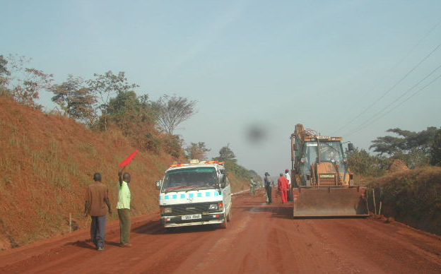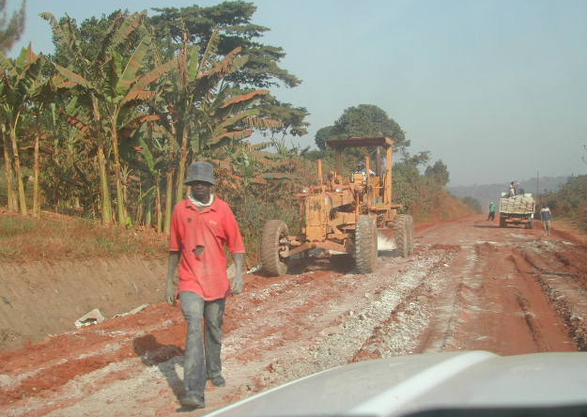

Plate 1c. PPE hung unused inside switchboard room Plate 1d. Consulting with workers on use
At Kakabara quarry site. of PPE at Kyegegwa Kakabara road works.
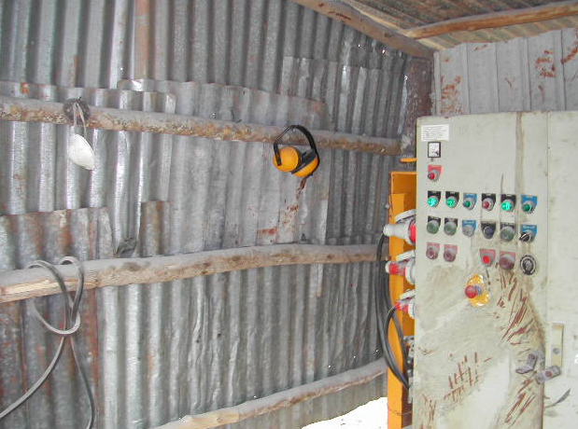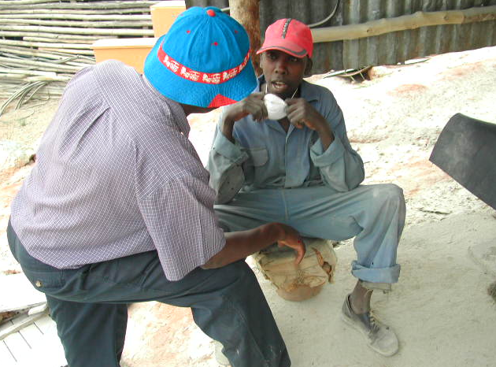

Plate 2a. Interface of reserve and road under Plate 2b. Dust raised during the mechanized
Construction-no warning sing at junction brushing exercise- Wankulukuku Kabuusu works.
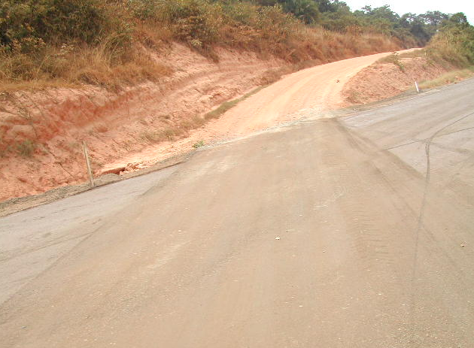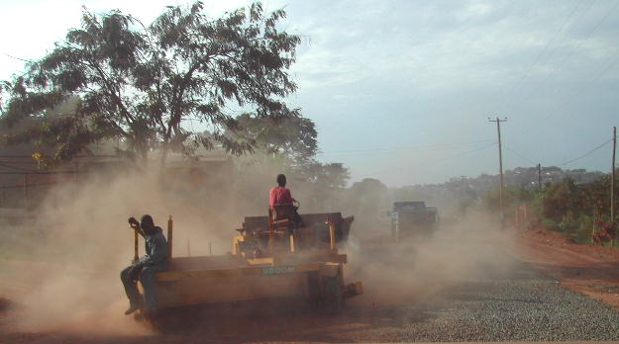

Plate 3a. Consulting with contractors- Stirling. Plate 3b. Consulting with roads consultant.
Renerdett Consulting Engineers.
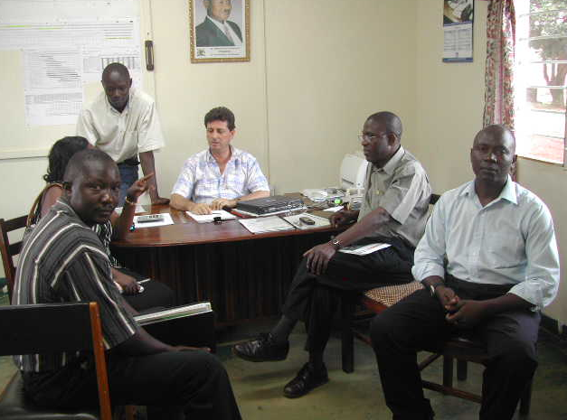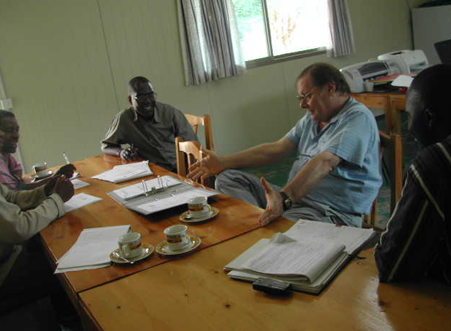

Plate 4a. Poor bath facility at contractor’s Plate 4b. Consulting with women workers along
Female staff residence (Serere- Kasilo corner) Serere- Kasilo corner LB Works.
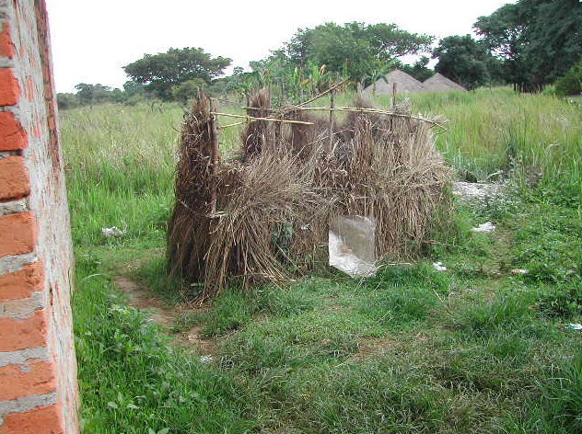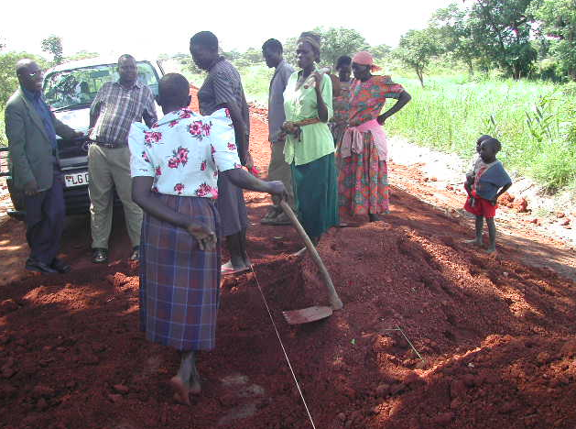

Plate 4c. A baby of one of the workers resting along Plate 4d. Water source at men workers’
Serere – Kasilo corner LB Works. Camp site (dangerous pit without fence)
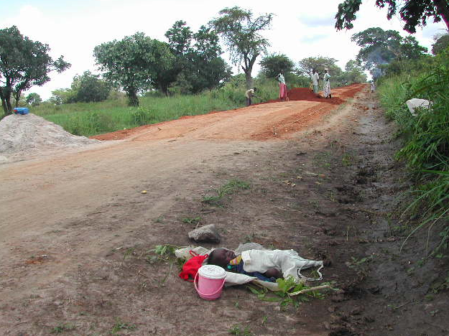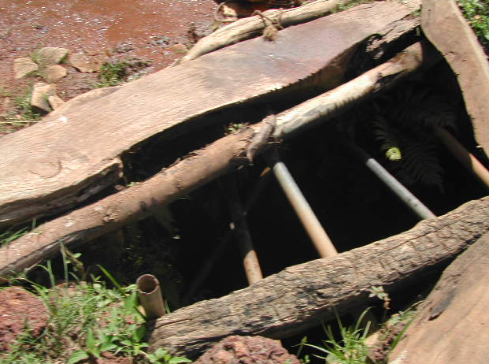

Plates 1a. –1d. taken 7/10/2004
Plates 2a. and 2b. taken 6/26/2004
Plates 3a. and 3b. taken 10/15/2004
Plates 4a. – 4d. taken 6/25/2004.

Workplace Safety and Health: Guidelines for District Engineers , 2003

